SIMATS ENGINEERING
CO3 – AT1 EXPERIMENTS
COURSE NAME: Cryptography and Network Security
COURSE CODE: CSA5160
NAME: BHUVANESHWARI B A REG NO: 192421195
1) MD5 and SHA-256 Hash Generation and Comparison
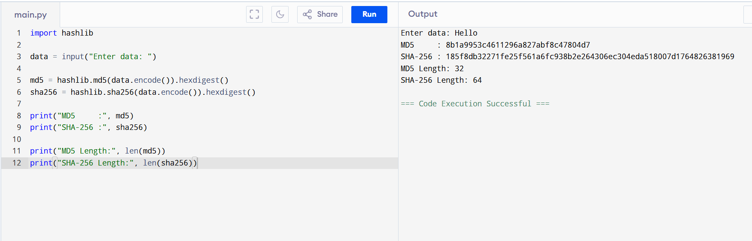
2) SHA-256 Hashing for Data Integrity Verification
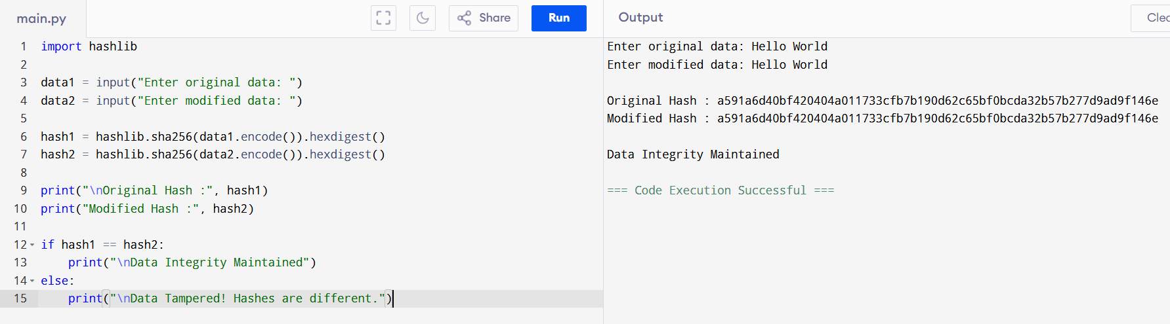
3) SHA-256 Hashing for Data Integrity Verification
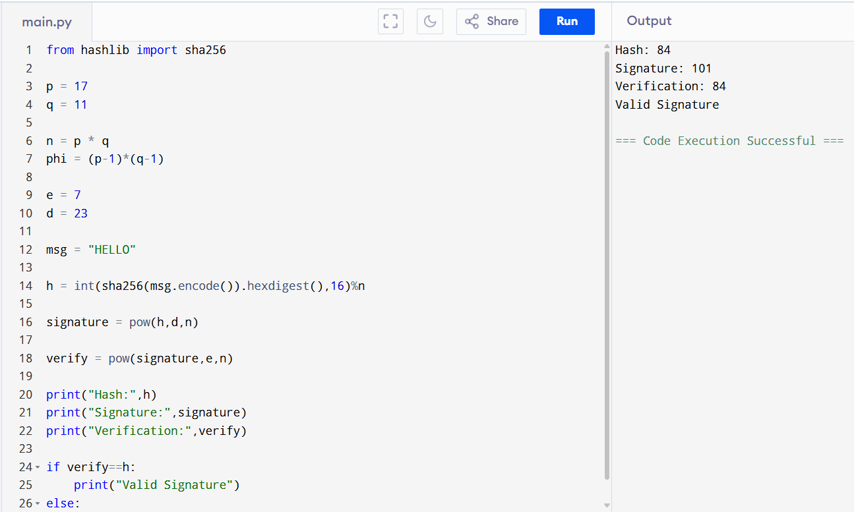
4) Simplified Kerberos Authentication
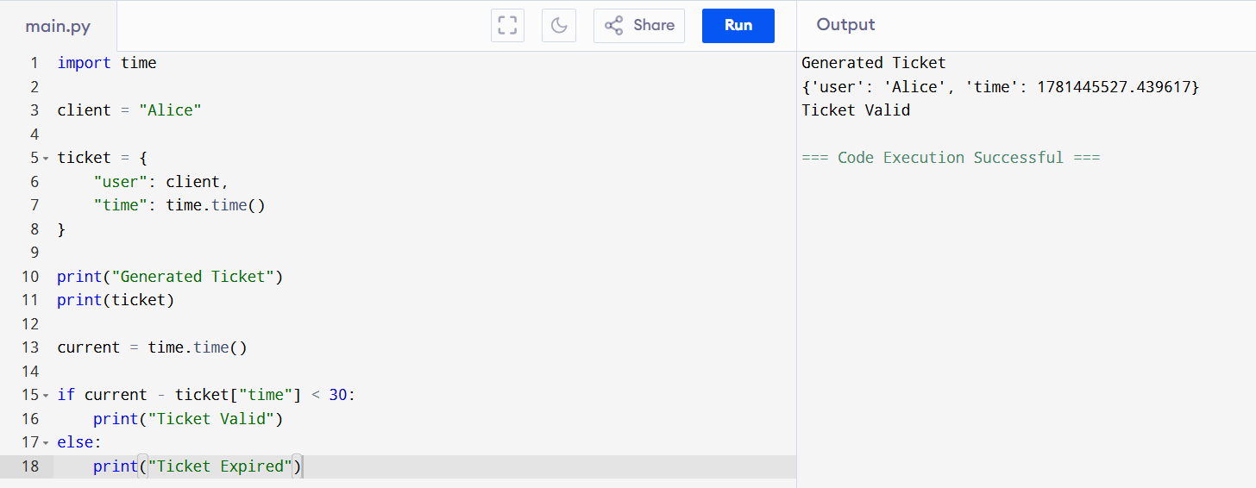

5) X.509 Certificate Parser and Validator